Multi-physics optimization of an integrated modular motor drive system

M Uğur, O Keysan

Department of Electrical and Electronics Engineering, Middle East Technical University, Ankara, Turkey
ugurm@metu.edu.tr keysan@metu.edu.tr

Keywords: integrated motor drive, modular motor, permanent magnet synchronous machine, gallium nitride, interleaving

Abstract
In this paper, a multi-physics approach is presented for the design optimization of and integrated modular motor drive (IMMD) system. The system is composed of a modular permanent magnet synchronous motor ad a GaN based modular motor drive inverter power stage. The multi-physics model includes the motor drive inverters and DC link capacitor bank (electrical model), the stator windings and rotor magnets (electromagnetic model), the heat sink (thermal model) and a spatial model. The main purpose of the design optimization is to obtain the highest power density, which is quite critical in integrated drives. As the system has several interdependencies due to integrated structure, selection of parameters is based on those relationships. A 8 kW IMMD system design is proposed and the resultant system is simulated using various simulation platforms for verification.

1 Introduction
Conventional variable frequency motor drive systems are composed of two distinct parts: the drive and the motor, where drive units are placed in separate cabinets and connected to the corresponding motors with long cables. This causes reduction in the overall system power density, cost increase and electromagnetic interference (EMI) problems [1]. In integrated modular motor drive (IMMD) systems, the drive is integrated onto the motor back iron forming a single package such that the power density of the overall system is enhanced and the connection cables are eliminated [1]. Furthermore, each pole of the motor is driven by its own drive module which are then interconnected via a common DC link. By doing so, the fault tolerance of the system is increased, heat dissipation is spread on a wider surface area and voltage stress on windings and power semiconductor devices are reduced [2].

In IMMDs, the space available for the drive system components is drastically reduced due to integration. Therefore, fitting all the components requires design optimization with integrated model approach and careful spatial and layout design. Moreover, the interdependencies between the main system components yields a multi-physics approach where the design of motor, drive power electronics and thermal management system should be considered all together. Therefore, it is highly difficult to propose a decoupled design approach in integrated drives as one may affect the other significantly [3].

The current IMMD prototypes proposed in the literature are usually based on new generation wide band-gap power semiconductor devices, such as Gallium Nitride (GaN) power FETs [4]. These devices are capable of switching at much higher switching frequencies compared to their silicon counterparts with low switching losses [5]. It is possible to reduce the size of passive components with high switching frequencies as well as reduce the size of heat sink with superior efficiency values with the utilization of enhancement mode (e-mode) GaNs. Considering that the largest components on an average power converter system are passive components and the heat sink [1], utilization of these devices is critical for IMMD designs. Moreover, thanks to the modularity of the system, interleaving technique can be used to further reduce the size of DC link capacitor bank [6]. Although several studies have been published regarding power electronics design, modular inverter topologies, DC link capacitor selection etc. for IMMDs [1,3,7,8], most of these prototypes lack a unified design. One example for such a dependency is that, the cross-sectional area available for the motor drive printed circuit board (PCB) and heat sink is determined by the diameter of the motor.

In this paper, optimum design of an IMMD system is presented considering both the motor and drive parameters to obtain the highest power density. It is also aimed to maximize the overall system efficiency which keeping the active material costs in acceptable limits. A permanent magnet synchronous motor (PMSM) having fractional slot concentrated winding (FSCW) stator is utilized for its superior torque density, low cogging torque and fault tolerance capability which makes it suitable for IMMD applications [9]. The content of the multi-physics design optimization approach includes electrical, electromagnetic, thermal and spatial models. First, the multi-physics model is presented in Section 2. In section 3, the basic relations between the system parameters and the cost and constraint functions are obtained and the inter-dependencies are discussed. Using the results of Section 3, an optimum system design is proposed in Section 3. In Section 4, the presented models are verified and the proposed system design is evaluated using simulation results. The paper is concluded in Section 5.

2 System modelling
Motor drive integration onto the modular stator back iron is considered in this paper, an example of which is shown in Fig. 1 [7]. The structural configuration of the proposed system is also shown in Fig. 2.

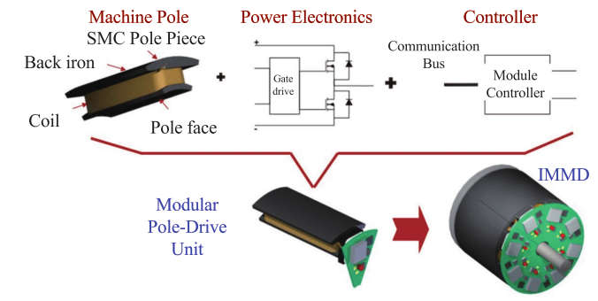
Figure 1. An example of the IMMD structure [7]

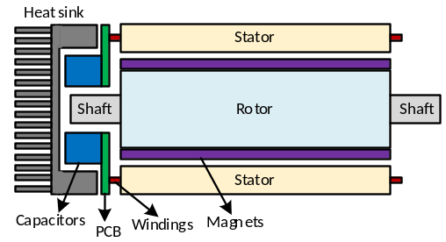
Figure 2. Structural configuration of the proposed IMMD

The fundamental blocks of the system model and the coupling of different aspects used in the integrated design are shown in Fig. 3. Basically, the system is composed of the electrical model, electromagnetic model, thermal model and spatial (geometric) model. The system specifications and constraints are listed in Table 1.

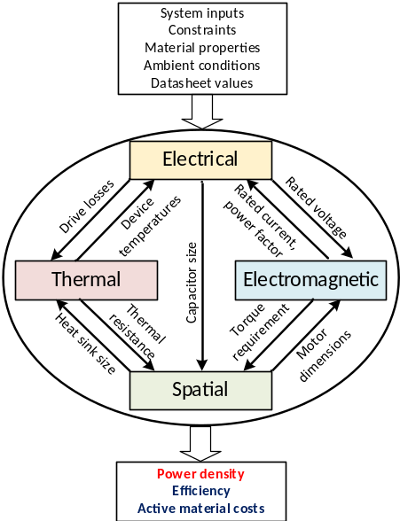

Figure 3. Fundamental blocks of the system model

Moreover, the variables (optimization parameters) and their corresponding sub-models are also shown in Table 2.

Parameter | Value
DC link voltage, V_{dc} | 540 V
Number of phases in each module, m | 3
Motor total output power, P_{out} | 8 kW
Motor rated speed, N_{r} | 600 rpm
Machine electric loading, A_{rms} | 35 kA/m
Machine magnetic loading, B_{avg} | 0.6 T
Maximum winding current density, J_{rms} | 4 A/mm²
Maximum stator teeth flux density, B_{ts} | 1.8 T
Maximum stator yoke flux density, B_{ys} | 1.4 T
Maximum fill factor, k_{cu} | 0.6
Maximum device junction temperature, T_{j-max} | 150 ⁰C
Maximum capacitor temperature, T_{cap-max} | 70 ⁰C
Minimum motor efficiency, η_{m-min} | 94 %
Minimum drive efficiency, η_{d-min} | 98 %
Magnet residual flux density, B_{r} | 1.25 T
Magnet relative permeability, µ_{r} | 1.1
Ambient temperature, T_{amb} | 50 ⁰C
Stator and rotor stacking factor, k_{s} | 0.95

Table 1. System specifications and constraints

Optimization parameters | Sub-model
Number of modules, n | Electrical
Number of series modules, n_{s} | Electrical
Switching frequency, f_{sw} | Electrical
Modulation index, m_{a} | Electrical
Aspect ratio of the motor, α | Electromagnetic
Magnet length, l_{m} | Electromagnetic
Slot/module/phase, w_{s} | Electromagnetic

Table 2. Optimization parameters

Assumptions

2.1 Electrical sub-model
The electrical model includes, determination of rated parameters of the motor drive inverter, selection of power semiconductor devices, calculation of motor drive losses, determination of required DC link capacitor parameters and selection of DC link capacitors.
A set of 650V e-mode GaN FETs suitable for high voltage applications having different current ratings from GaN systems are used for the design [ref].

Total harmonic distortion’dan bahsetmeli miyiz?

2.2 Electromagnetic sub-model
M250-50A core material
NeFe40 magnet

PA + A’P - PBR⁻¹B’P + Q = 0. (1)

slot yapısı figür

Figure X. Machine geometry and slot structure

Cogging torque ve torque ripple’dan nasıl bahsedelim??

2.3 Thermal sub-model
Equations

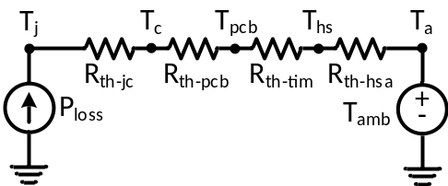

Figure X. Lumped parameter thermal equivalent circuit at steady state

2.4 Spatial sub-model
Equations

3 Dependencies between design parameters
The final format in which the papers will appear in the
Değişken parametreler: modül sayısı + seri modül sayısı, anahtarlama frekansı, magnet kalınlığı, aspect ratio, slot/module/phase, ma
Bakılacaklar: motor verimi, drive verimi, power density, Active material cost (mass)?, GaN ve Cap costu

4 Optimum system design
Your full paper should be submitted

5 Simulation results
Your full paper should be submitted
Modellerin verification’ı ???

6 Conclusions

An 8kW, 540V DC link system is designed using the developed optimization tool.
The resultant system has the performance indices of x kW/lt, x % drive efficiency and y % motor efficiency

Acknowledgements
This work is partially supported by Scientific and Technological Research Council of Turkey (TUBITAK) under the TUBITAK project number 117E252.

References
[1] G. Lo Calzo, G. Vakil, B. Mecrow, S. Lambert, T. Cox, C. Gerada, M. Johnson, and R. Abebe, “Integrated motor drives: state of the art and future trends,” IET Electr. Power Appl., vol. 10, no. 8, pp. 757–771, Sep. 2016.
[2] M. D. Hennen, M. Niessen, C. Heyers, H. J. Brauer, and R. W. De Doncker, “Development and control of an integrated and distributed inverter for a fault tolerant five-phase switched reluctance traction drive,” IEEE Trans. Power Electron., vol. 27, no. 2, pp. 547–554, 2012.
[3] S. M. Lambert, B. C. Mecrow, R. Abebe, G. Vakil, and C. M. Johnson, “Integrated Drives for Transport - A Review of the Enabling Electronics Technology,” IEEE Veh. Power Propuls. Conf., pp. 1–6, 2015.
[4] J. Wang, Y. Li, and Y. Han, “Integrated Modular Motor Drive Design With GaN Power FETs,” IEEE Trans. Ind. Appl., vol. 51, no. c, pp. 3198–3207, 2015.
[5] J. Wang, Y. Li, and Y. Han, “Evaluation and design for an integrated modular motor drive (IMMD) with GaN devices,” 2013 IEEE Energy Convers. Congr. Expo. ECCE 2013, no. Immd, pp. 4318–4325, 2013.
[6] M. Ugur and O. Keysan, “DC link capacitor optimization for integrated modular motor drives,” 2017 IEEE 26th Int. Symp. Ind. Electron., vol. i, pp. 263–270, 2017.
[7] J. Wang, Y. Li, and Y. Han, “Integrated Modular Motor Drive Design With <roman>GaN</roman> Power <roman>FETs</roman>,” IEEE Trans. Ind. Appl., vol. 51, no. 4, pp. 3198–3207, 2015.
[8] A. Shea and T. M. Jahns, “Hardware integration for an integrated modular motor drive including distributed control,” in 2014 IEEE Energy Conversion Congress and Exposition (ECCE), 2014, pp. 4881–4887.
[9] N. Bekka, M. E. H. Zaim, N. Bernard, and D. Trichet, “A Novel Methodology for Optimal Design of Fractional Slot with Concentrated Windings,” IEEE Trans. Energy Convers., vol. 31, no. 3, pp. 1153–1160, 2016.

